**Name** : Malaika

**Surname :** Metsing

**Identification number :** 022125134084

**Module :** Into To Web Development

**WEBSITE DEVELOPMET ANALYSIS REPORT**

1. Starting out getting in the html section of the coding, I have not run into any mishaps or any issues with structuring the head and the introduction of the body and getting to inputting the navigation bar of the landing page as well as styling the cover page.
2. General coding experience - Overall there had not been any drastic stress from the general coding experience as well as developing the website itself. There had been only an issue with time, find the right resources for the features that I want to implement/include and the amount of time it took to even complete the development of the website.

**COVER PAGE**

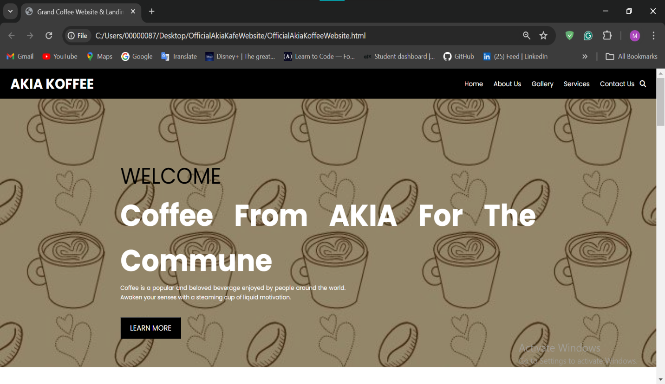

**ABOUT US**

**MENU PAGE LANDING PAGE**

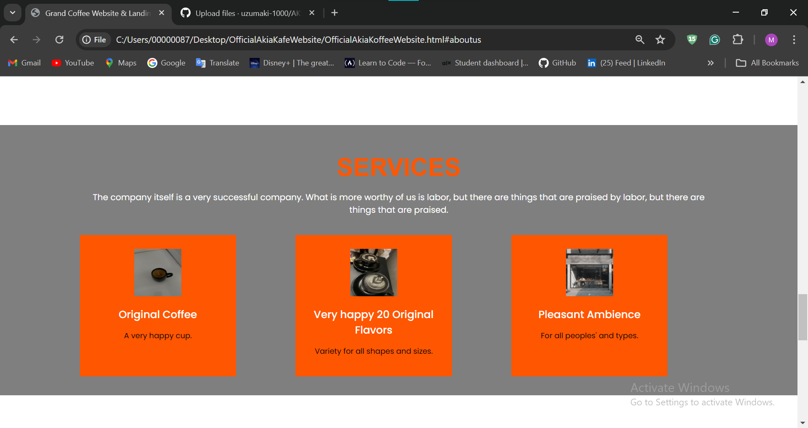

**CONTACT US**

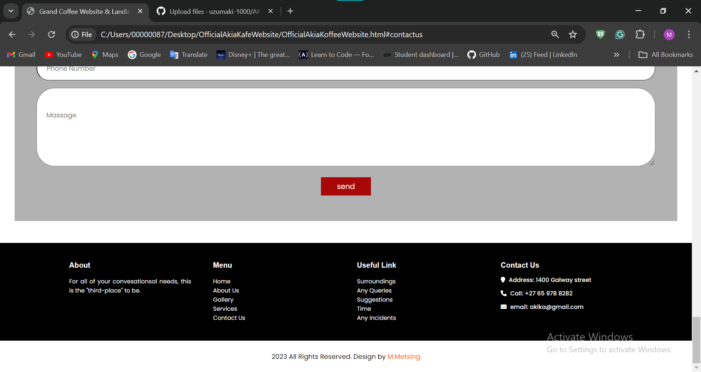

**GALLERY**

